Report Module

ET’s Report Module is probably its most powerful in terms of workload reduction potential.

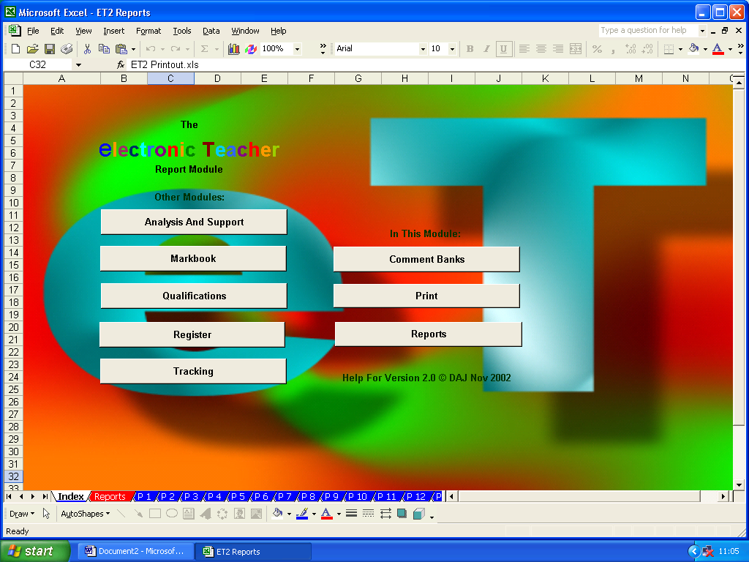

As ever, the first stage with the Report Module is to set it up…first the comment banks. These can be accessed from the comments navigation sheet.

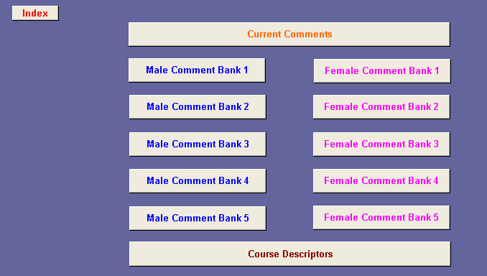

The module can contain up to five sets of course descriptions. These are intended to be short and succinct descriptions of the part of the course to which the current set of reports correspond. The descriptors are simply typed into relevant descriptor cell.

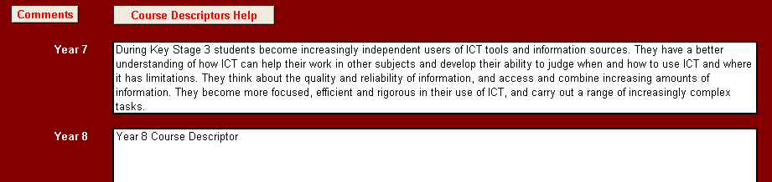
To ensure comprehensive and consistent comments are used for each student, the comment banks can contain up to 15 sub-sections. Each sub-section’s title should be entered in the table at the top of the comment bank. On entry these are then shown next to the individual comments for that sub-section.

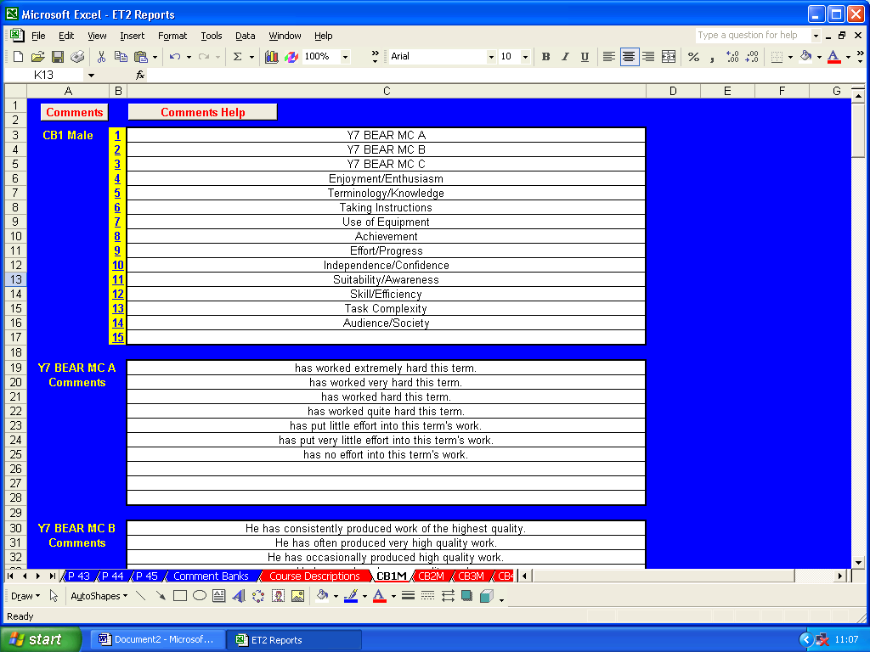

Up to 10 individual comments can be entered for each sub-section by typing them into the relevant cells. Two sets of comments need to be created, one for male students and one female. These can be created so they can be used with individual student’s name or using subject, object or possessive pronouns.

Individual comments can be created as whole, stand alone sentences.

Alternatively, comments can be created by combining front end, middle and/or back end sentence sections. Here, an example of a set of female comment starts with alternative and contrasting comment ends.

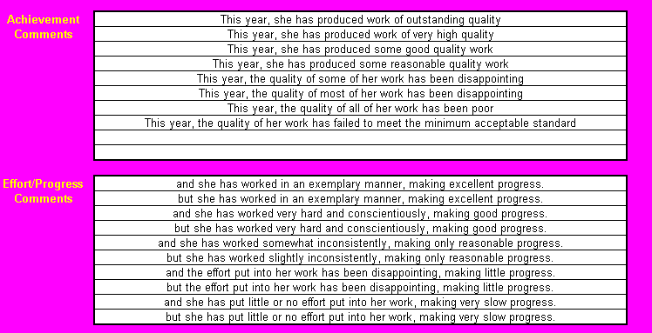

On completion, the whole set of comment sub-sections and male and female comments or comments sections can be seen on the Current Comments sheet.

Navigation to individual sub-sections can be facilitated by clicking on the numbered hyperlinks next to each sub-section title.

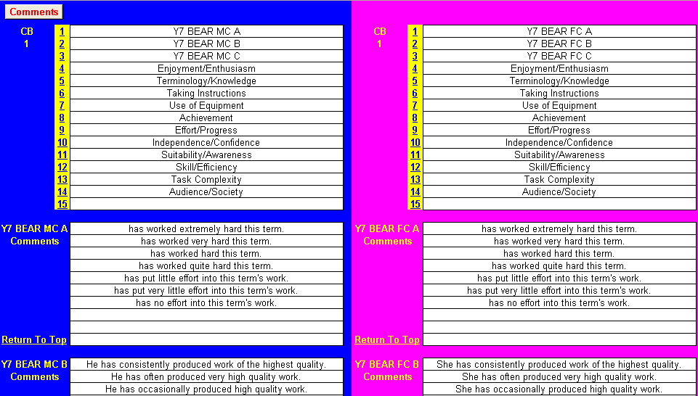
As ever, student details on the main report sheet are populated from the main markbook.

To complete the setup, add the date of issue, staff name and subject title and, finally, enter the number of the comment bank to be used.

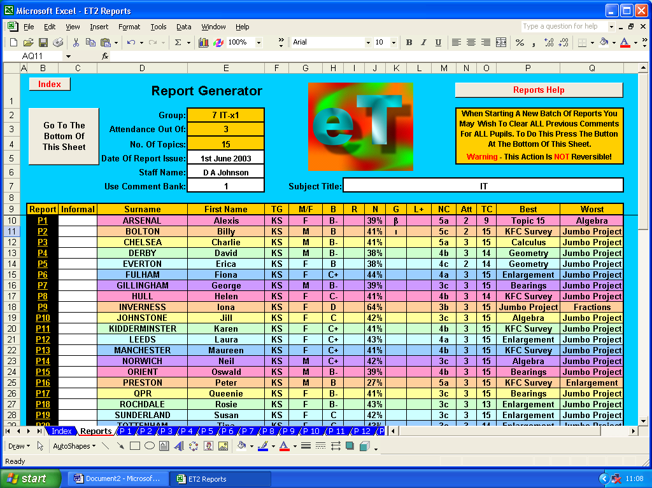

Should you wish to use informal names in the body of your reports, these can be added at this point.

If this is your first set of reports, the report generator will obviously be clear. However, if it has already been used to create a set of reports, you may wish to bulk clear previous comments. To do this, follow the instructions and note the warnings on screen…

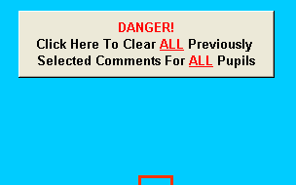

The set up is now complete…let’s move on to creating individual reports for individual students. Move to the report for an individual student by clicking on the appropriate “P1”, “P2”, etc. hyperlink in the leftmost column for that student.

The individual report sheet tries to help report creation.

Sub-section titles and gender sensitive comments are automatically displayed.

Individual student details are automatically displayed on the report generator including name, tutor/teaching group, assessment averages, work completed and attendance.

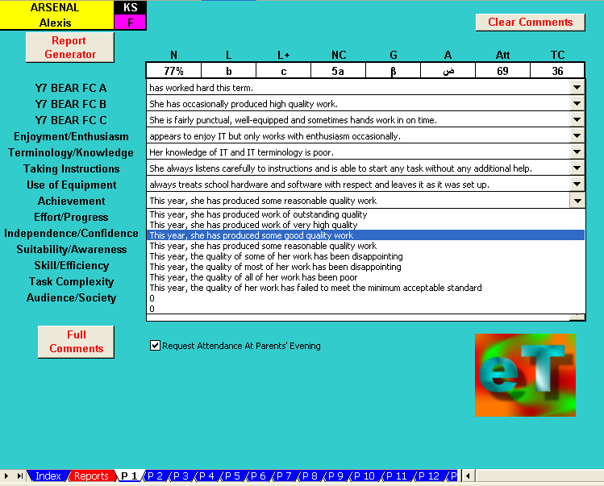

Comments for each sub-section are available on drop-down menus and can be selected merely by clicking on them.

Mail merge templates can be created from scratch for different types of report. Alternatively, those provided with ET can be used or amended.

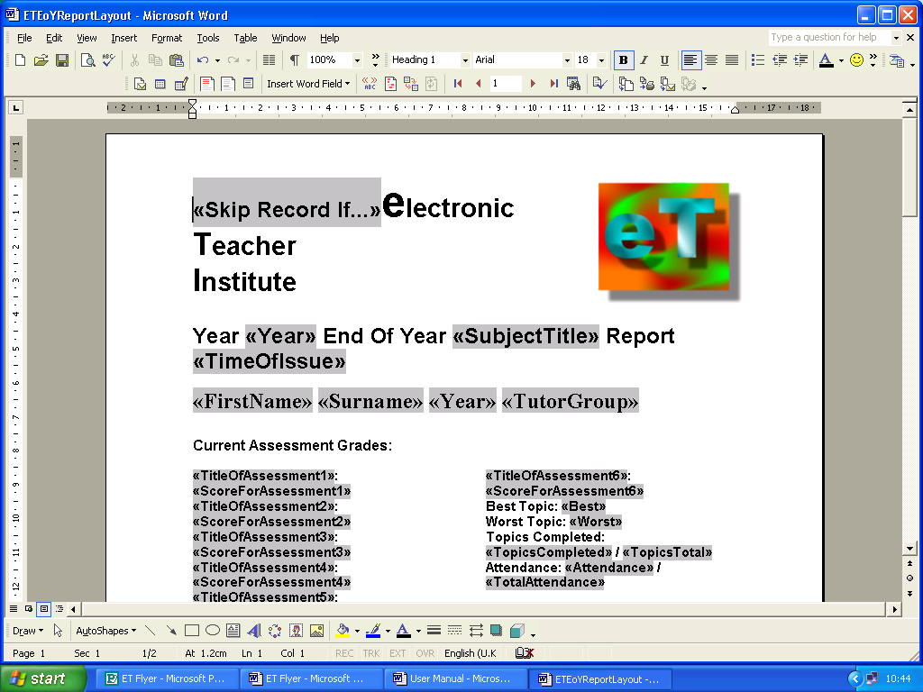
The templates included with ET not only insert the comments but will also insert the comment category titles.

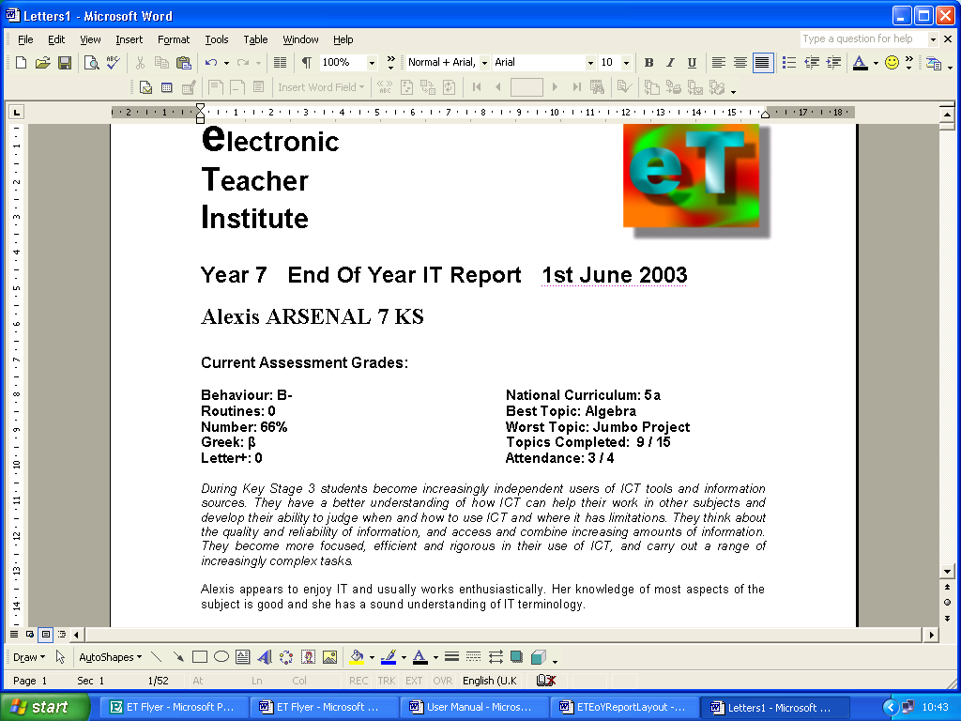

It will even produce a copy automatically…

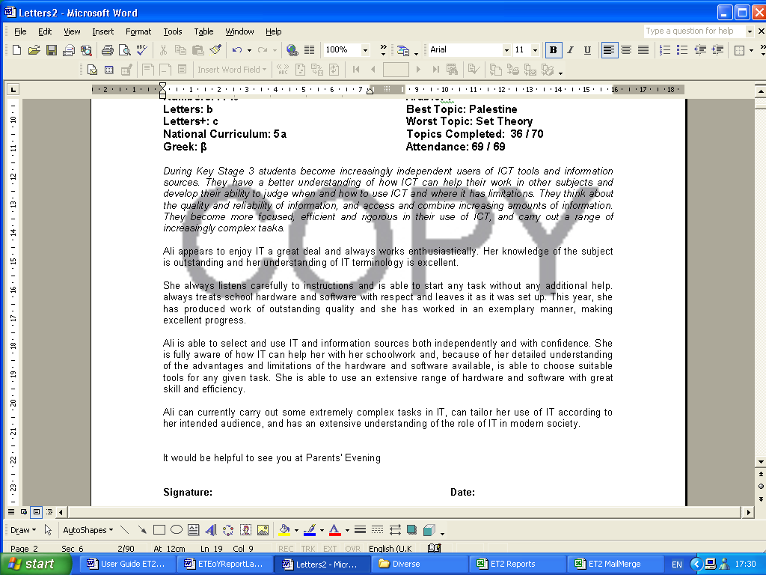

Ultimately, ET produces high-quality, individualised, comprehensive reports that, if required, can be amended or can even re-written from scratch…however, as student details and scores are automatically inserted, this still constitutes a considerable reduction in workload.

Enough for any UK school Key Stage or degree course.
If more than ten comments are needed for a particular section, two or more sub-sections blocks can be used.
He, him, his…she, her, her.
These can be used for reference if comments or sections are too large to fit in individual report genitors drop-down menus. See later.
“Chris” instead of “Christopher”, for instance.

